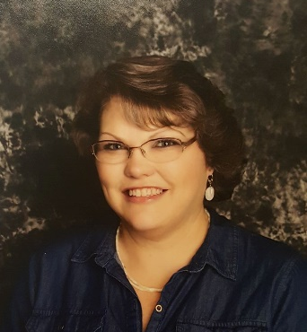

Personal Biography

My name is Jamie Cook. I am married with 3 grown children and one
Grandson and 2 on the way. When I’m not working, I love cooking and baking, kayaking, and Camping. I have a true passion for Early Childhood Education and young children
with special needs.

I am currently the Director for Bayshore Learning Center, in La Porte, Texas. I have been
an early childhood educator for 18 years, and I have taught ages that include infants through Pre-Kindergarten, spending most of my career with toddler 2’s and 3’s. Besides working in independent centers, I have owned my own home center for children with special needs (ADHD, Autism, ODD). I have a AAS from San Jacinto College in Child Development-Early Childhood Education, a BAS from the University of Houston Clear Lake in Early Childhood Program Leadership, and I am currently a Graduate student at American Public University, working to attain my master’s Degree in Education with a dual concentration in Teaching and Autism.

I have been the Director of Bayshore Learning Center for 2.5 years. I love that our center is a Christian learning center with a play-based philosophy, which means we encourage the love of the Lord through our teaching of other educational and social skills during play, art, music and much more.

We look forward to serving you and your family!

